
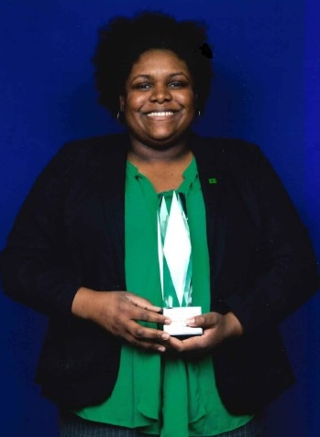
Aminah Harris (She/Her)
Senior AML Compliance Manager

Biography
Aminah Harris joined TD Bank, N.A. in September 2010. Aminah's mandate is focused on two Personal and Commercial programs (a) Transaction Monitoring and (b) Monitoring Program. She earned a BA-Economics and MBA- Professional Accounting from Rutgers University-Newark.
In addition, she holds the Certified Fraud Examiner (CFE) and Certified Anti-Money Laundering Specialist (CAMS) designations.
Aminah is passionate about people development, adding value to the organization and identifying/mitigating risk.
Outside of TD, her hobbies can best be described as "tinkering" and spending time with her wife, family and friends.
Presenter Biography

